

**Advanced Technological Institute – Kurunegala**

**Higher National diploma in information Technology**

**(HNDIT)**

HNDIT 2404

Project (Individual)

Supervisor: Ms.P.G.R.N.J.Gamlath

**SMART WHEELCHAIR FOR PATIENTS**

**G.W.Milinda Dilshan - KUR/IT/2020/F/10**

**Contents**

**1. Introduction** 3

**2. Background Motivation** 4

**3. Problem in Brief** 4

• **Being able to protect yourself from falling down stairs, pits, etc.** 5

• **Minimizing the risk of accidentally hitting obstacles in front or behind.** 5

**5.1 Aims** 6

**5.2 Objective** 6

**6. Recourses Requirement** 7

**6.1 Hardware Requirement** 7

**6.2 Software tool and technologies Requirement** 8

**7. Outline plan of the wheelchair** 8

**8. Gantt chart** 9

**9. Cklient Details** 10

**10. References** 10

# **1. Introduction**

I hope to make a wheelchair using Arduino technology under this project. I intend to use some more advanced tricks on it than a normal wheelchair.

This design is produced based on patients suffering from diseases like paralysis. This wheelchair is designed so that the patient can control it alone with one hand without a partner. Arduino technology is used here. This design works just like a regular electronic wheelchair.

But there are some special features for this. If the chair were to accidentally fall down a place such as a stairwell or pothole while moving forward in some way, it would shut off before the chair reached the spot. It is a very good safety measure. Additionally, it detects obstacles in front and behind the chair and turns the chair off before colliding with them. This contains another very special quality. If the patient suddenly falls ill on the chair, an emergency signal can be issued through a call or text message to the phone of the guardian by activating the emergency button installed on the chair. Lights that turn on automatically in the dark are also included. The footrest of the wheelchair can be raised and lowered by motors for the convenience of the patient. Another special feature here is. Patients who are unable to walk can defecate on their own, reversing the chair to the commode without hitting obstacles. For that, the chair has a specially made hole that can be opened by motors. There the chair is covered with waterproof covers to protect it from water. As a combination of all these, the final output can be created as user friendly.

# **2. Background Motivation**

Though the recent developments of science and technology has drastically changed the way a normal person lives his life , there are certain groups of people who have not been able to be benefit from this development. On particular handicapped people with have limited mobility are still living a miserable life.

A smart wheelchair It aims to help patients suffering from diseases like paralysis and people with physical disabilities by providing them with some form of safe mobility.

Smart wheel chair consists of a major controller unit which allows the user to provide the input in the form of joystick. The controller unit then synthesizes the command and takes required action so as to move the wheelchair to the particular position. If the patient suddenly falls ill on the chair, an emergency signal can be issued through a call or text message to the phone of the guardian by activating the emergency button installed on the chair.

# **3. Problem in Brief**

Movement is essential for every human being. So can every man walk? Difficulty in movement is a big problem for human. This directly affects paraplegics and disabled people in particular. Nowadays everyone is very busy with their work. It is very difficult to make an appointment for a patient. Such patients can use this device alone. It contains special safety measures to ensure a very safe journey for the patient traveling alone. Therefore, the creation of this product can be taken as a new cleansing for the mentality and thought pattern of such patients and caregivers.

**4. Proposed solution**

* **The patient is able to control the wheelchair independently.**

This wheelchair is designed so that the patient can control it alone with one hand without a partner. The chair can be easily moved around with a joystick. This design works easily like a regular electronic wheelchair.

# **Being able to protect yourself from falling down stairs, pits, etc.**

If the chair were to accidentally fall down a place such as a stairwell or pothole while moving forward in some way, it would shut off before the chair reached the spot. It gives more protection to the patient.

# **Minimizing the risk of accidentally hitting obstacles in front or behind.**

Here the sensors installed in the chair detect the obstacles in front and back and disable the chair before it collides with them.

* **Ability to emit signals to alert guardians in case of emergency.**

If the patient suddenly falls ill on the chair, an emergency signal can be issued through a call or text message to the phone of the guardian by activating the emergency button installed on the chair

* **Patient convenience.**

The footrest of the wheelchair can be raised and lowered by motors for the convenience of the patient.

**5. Aims and Objective**

## **5.1 Aims**

Mobility means moving from one place to another. A basic human need. Mobility is a difficult task for paralyzed and disabled people. Therefore, it is considered important to do it through a successful method. This process should be done simply and successfully in the successful completion of this project. I think this product is great for such people.

## **5.2 Objective**

* This product project is designed to be user friendly.
* This device can be easily used by someone with minimal electronics knowledge.
* A very safe product for patients.
* It can be designed with comfort as per the needs of the patients.
* Makes the daily work of disabled and sick people easier to some extent.
* Caregivers need not fear for the patient.
* Easy to use and maintain.

# **6. Recourses Requirement**

## **6.1 Hardware Requirement**

* CPU : Intel i3 10 gen processor or above
* CPU Speed : 2.5 GHZ or above
* Capacity:30 GB of Hard drive or above
* RAM requirement : 4 GB minimum
* **Dummy wheelchair** – ( Handmade by using wood and Chair rexine)

**Arduino technologies**

* **Arduino board** - The main function of the Arduino board is to control electronics through reading inputs & changing it into outputs because this board works like a tool. This board is also used to make different electronics projects in the field of electronics, electrical, robotics, etc.
* **Ultrasonic sensor** – Calculation of the distance to the ground and identifying barriers
* **GSM Module** - The Arduino GSM shield allows an Arduino board to connect to the internet, send and receive SMS, and make voice calls using the GSM library.
* **Motor Shield** - It lets you drive two DC motors with your Arduino board, controlling the speed and direction of each one independently.
* **Servo motors** - Servo motors are used to control the position of objects, rotate objects, move legs, arms or hands of robots, move sensors etc. with high precision.
* **joystick** - The joystick is a position sensor which returns two analogue values representing its X,Y position. It can be used as an interface to navigate a menu or to control an object in direction or speed.
* **Motors with wheels**
* **Jumper wire**
* **Buttons**
* **LED Lights**
* **Battery**
* **USB cable**

## **6.2 Software tool and technologies Requirement**

* Arduino Software
* AutoCAD Software

# **7. Outline plan of the wheelchair**

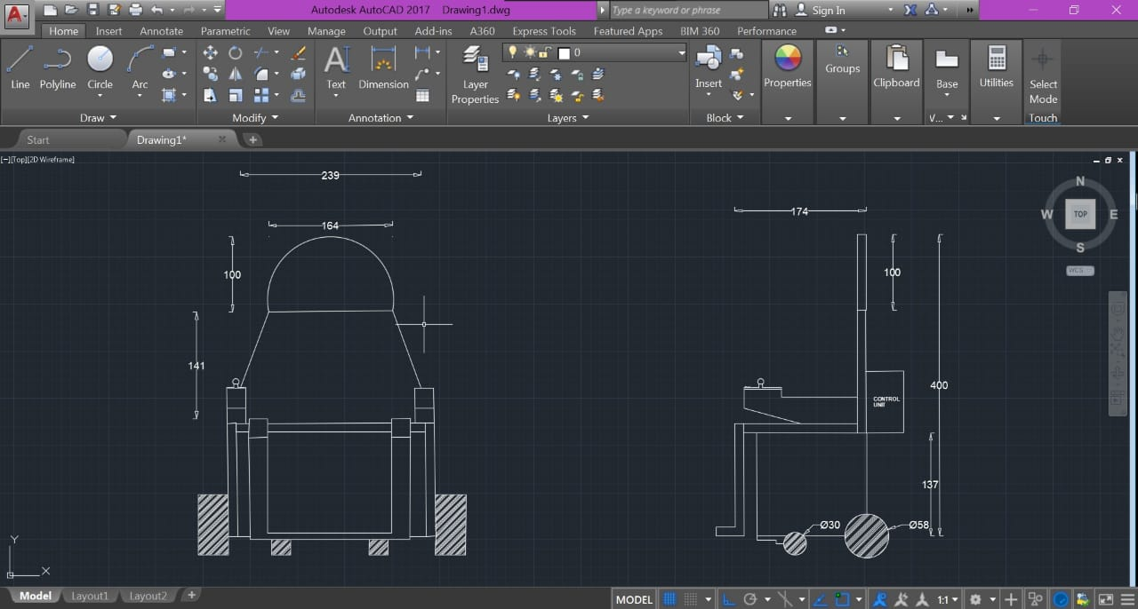

# **8. Gantt chart**

|  |  |  |  |  |  |  |  |  |  |  |  |  |  |
| --- | --- | --- | --- | --- | --- | --- | --- | --- | --- | --- | --- | --- | --- |
| Dates  Steps | March | | April | | | | May | | | | June | | |
| 3 | 4 | 1 | 2 | 3 | 4 | 1 | 2 | 3 | 4 | 1 | 2 | 3 |
| **1 Problem Definition** |  |  |  |  |  |  |  |  |  |  |  |  |  |
| 1.1 Research about the problem |  |  |  |  |  |  |  |  |  |  |  |  |  |
| 1.1 define Requirement |  |  |  |  |  |  |  |  |  |  |  |  |  |
| 1.2 Define specific functions |  |  |  |  |  |  |  |  |  |  |  |  |  |
| 1.4 Develop the project proposal |  |  |  |  |  |  |  |  |  |  |  |  |  |
| **2 Planning** |  |  |  |  |  |  |  |  |  |  |  |  |  |
| 2.1 Develop Scope statement |  |  |  |  |  |  |  |  |  |  |  |  |  |
| 2.2 3D drawing of wheelchair plan |  |  |  |  |  |  |  |  |  |  |  |  |  |
| **3 Design & coding** |  |  |  |  |  |  |  |  |  |  |  |  |  |
| 3.1 Wheelchair design & coding |  |  |  |  |  |  |  |  |  |  |  |  |  |
| 3.2 Attaching electronics to the wheelchair & coding |  |  |  |  |  |  |  |  |  |  |  |  |  |
| 3.4 Coding for proper functioning of wheelchair with electronics |  |  |  |  |  |  |  |  |  |  |  |  |  |
| **4 Implementation** |  |  |  |  |  |  |  |  |  |  |  |  |  |
| **5 Wheelchair testing** |  |  |  |  |  |  |  |  |  |  |  |  |  |
| **6 Deploy the wheelchair** |  |  |  |  |  |  |  |  |  |  |  |  |  |
| **7 Presenting final project** |  |  |  |  |  |  |  |  |  |  |  |  |  |

# **9. Cklient Details**

Name - R.M Kamal Shantha ( A Paraplegic )

Address - Karuwalagahawaththa, Maho.

Contact No - 071 - 7703776

# **10. References**

How to learn Arduino

<https://docs.arduino.cc/learn/starting-guide/getting-started-arduino>

How to learn Arduino

<https://www.freecodecamp.org/news/create-your-own-electronics-with-arduino-full-course/>

How to learn Arduino

<https://hackr.io/tutorials/learn-arduino> - (You tube tutorials )

How to learn Arduino ( You tube tutorials )

<https://www.youtube.com/@NisalHewagamage/about>

Arduino Official website

<https://www.arduino.cc/en/software>

Purchase of Arduino equipment

<https://microchip.lk/>

Purchase of Arduino equipment

<https://duino.lk/>